■Identifying Feelings (Grade 1)
Introduction: It is important for children to be able to name and talk about their feelings. This increases self-awareness and helps children gain a sense of control and mastery over their emotions and behaviour. Learning to identify feelings in oneself and others provides the necessary foundation for effective problem solving.

Activity 1:  How Does Carlos Feel? | Activity 2:  How Does Benjamin Feel?
Procedure:  Teacher says to children:  - Look at this picture.  - This boy’s name is Carlos.  - How is Carlos feeling? (Excited? Happy?)  - What do you think could have made Carlos feel this way?  - What are some things that make you feel the way Carlos is feeling?  N.B.: If a child said that Carlos feels scared, have the class suggest ways to make him feel better. | Procedure:  Teacher says to children:  - Look at this picture.  - This boy’s name is Benjamin.  - How does Benjamin feel?  - What do you think made Benjamin feel this way?  - What would make you feel this way?  - What could make Benjamin feel better?

Teaching Points:
- We have many different feelings. Sometimes our feelings are happy and sometimes feelings are sad.
- When you are angry or hurt, it is important to say how you feel and to respect how other persons feel.

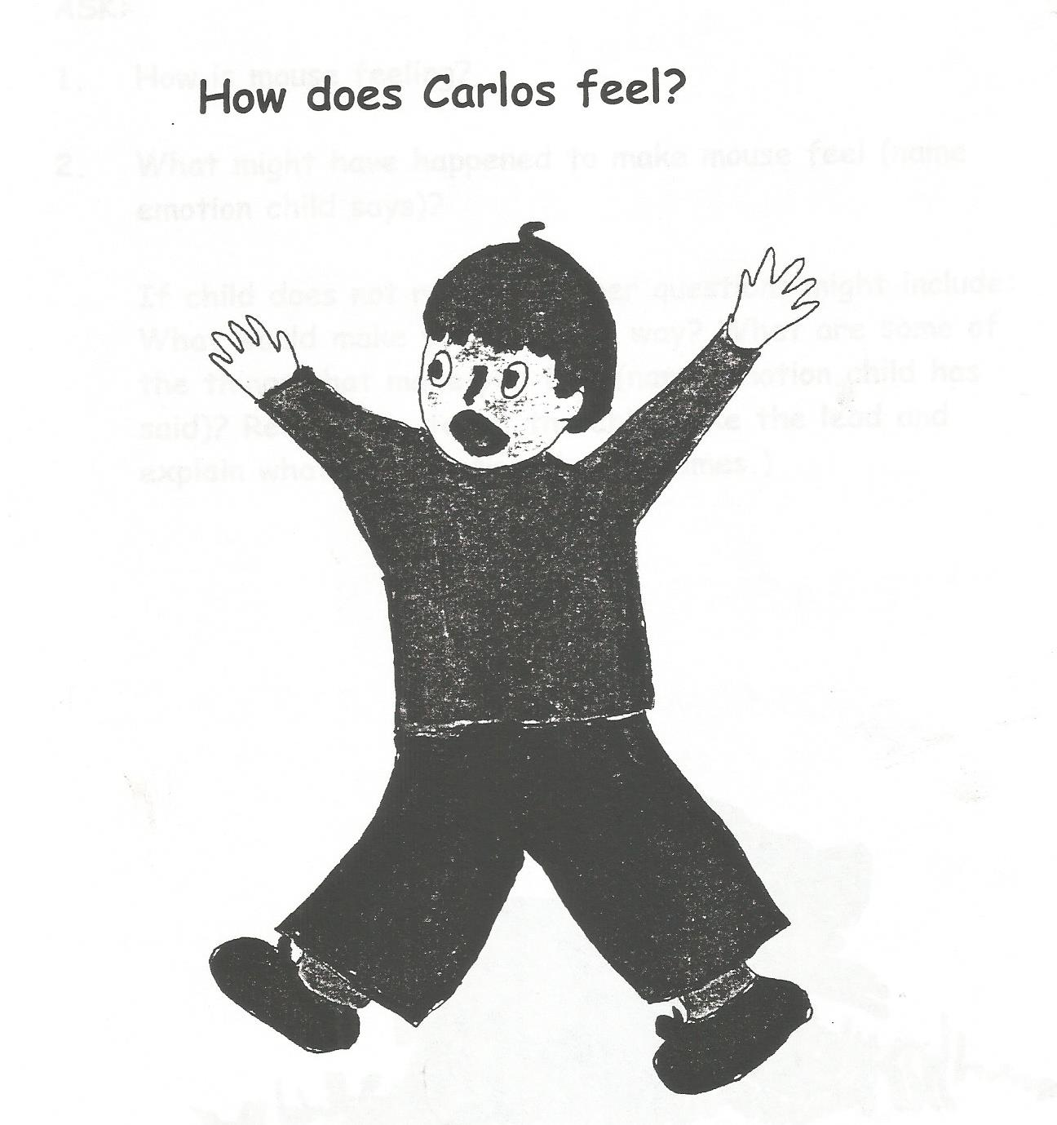

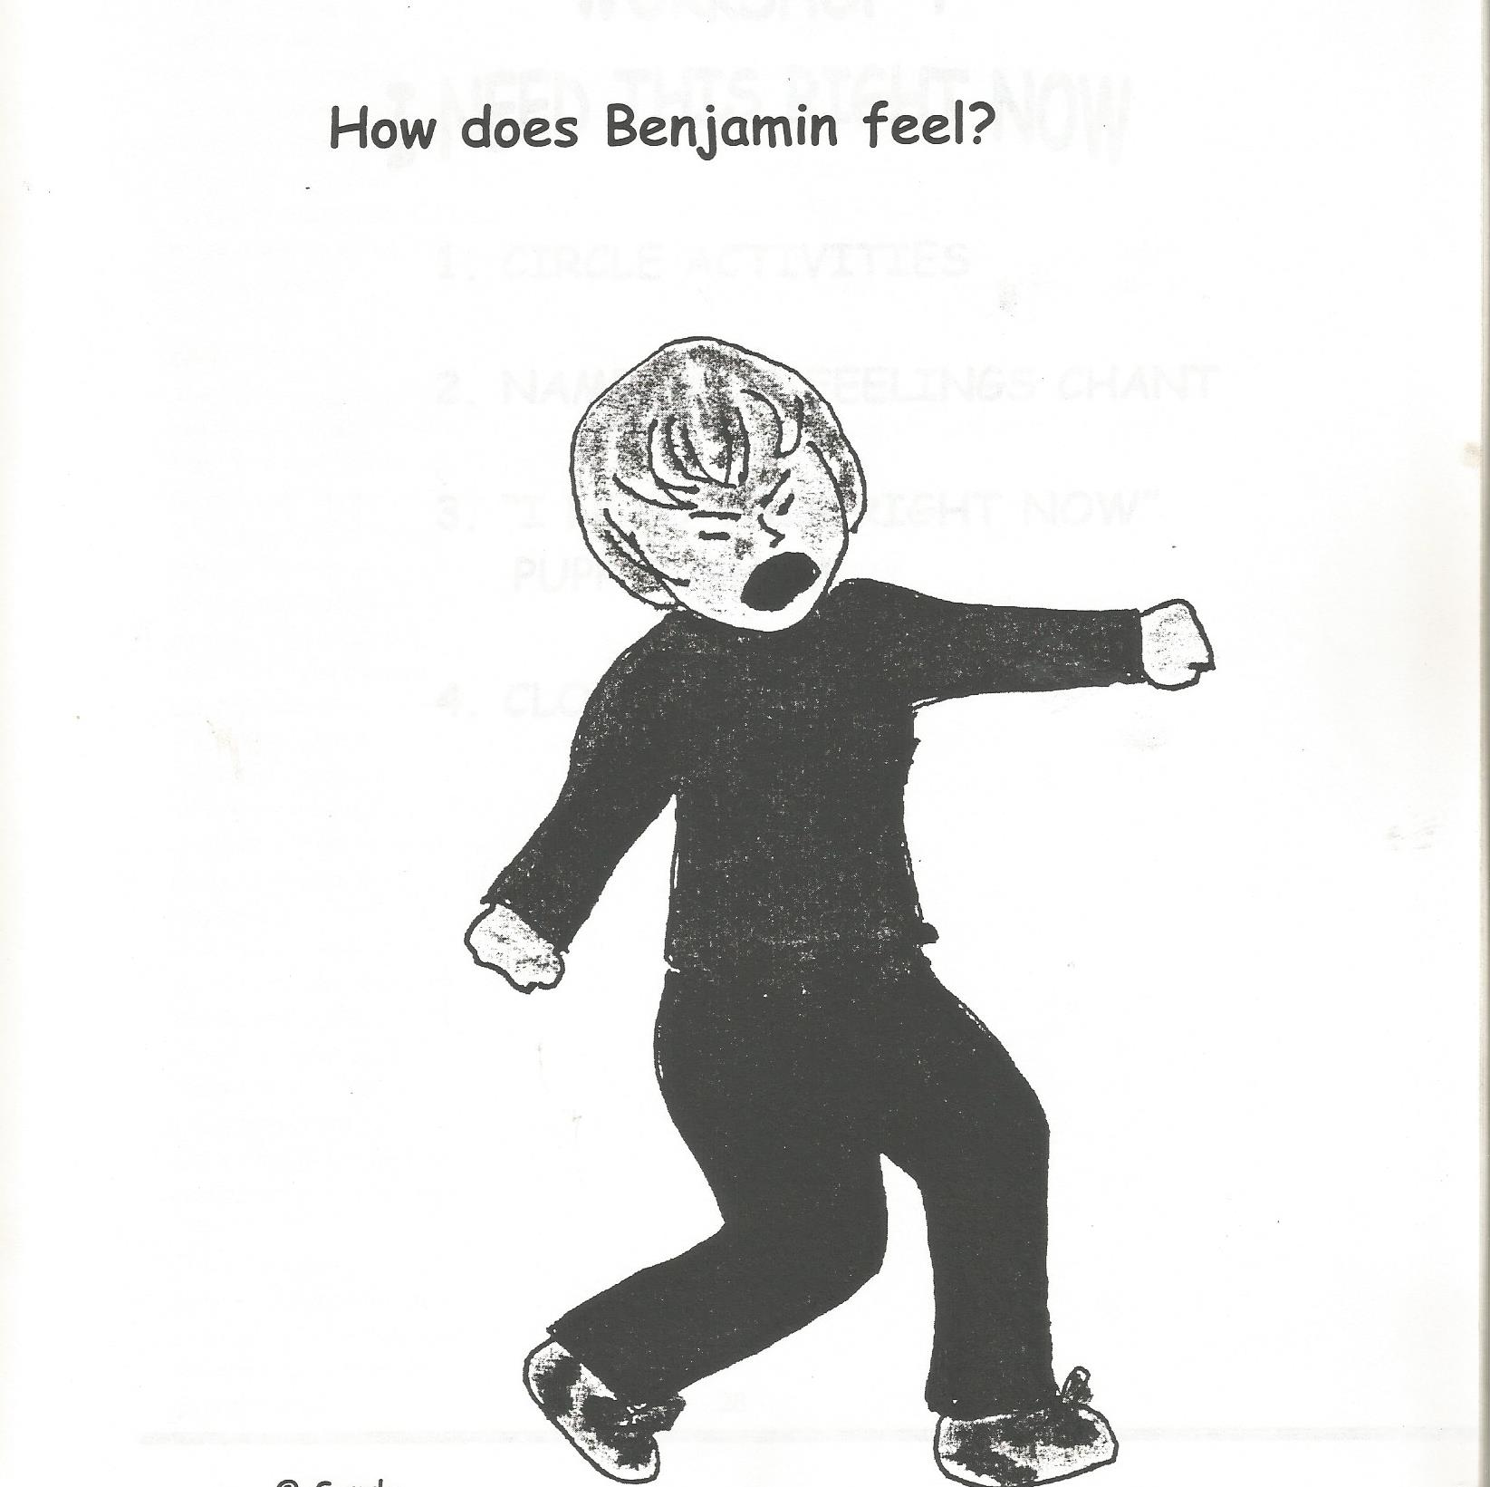

■ WE CARE ABOUT EACH OTHER’S FEELINGS (Grade 2 & 3)
Objectives:
- To understand and recognise that everybody has feelings.
- To identify some different feelings.
- To understand that it is important to name feelings when talking things out.

Procedure:
- Read the poem below. You may want the children to learn it and so they can recite it.
- Have students colour the pictures that show people caring about each other’s feelings.
- Have the students complete the sentences in the activity “My Feelings Count, Too”.
- Help them identify the feelings for the sentence completion.
- Teach them new feeling words and have them
  - Use the words in situations they have experienced
  - Draw pictures of the feeling words
  - Do facial expressions to show the feelings
  - Act out the feeling words – they can have their classmates guess the feeling word
  - Make an ABC book of feeling words

Teaching Points:
Say to the students:
- Peacemakers care about each other’s feelings.
- When you are angry or hurt, it is important to say how you feel and to respect how other persons feel.
- We have many different feelings. Sometimes our feelings are happy and sometimes our feelings are sad. It is important to know that it is okay to feel how you feel – just remember to respect yourself and others.
- Once we have talked and listened to each other, we can think about solutions to the problem that will make the situation better for us.

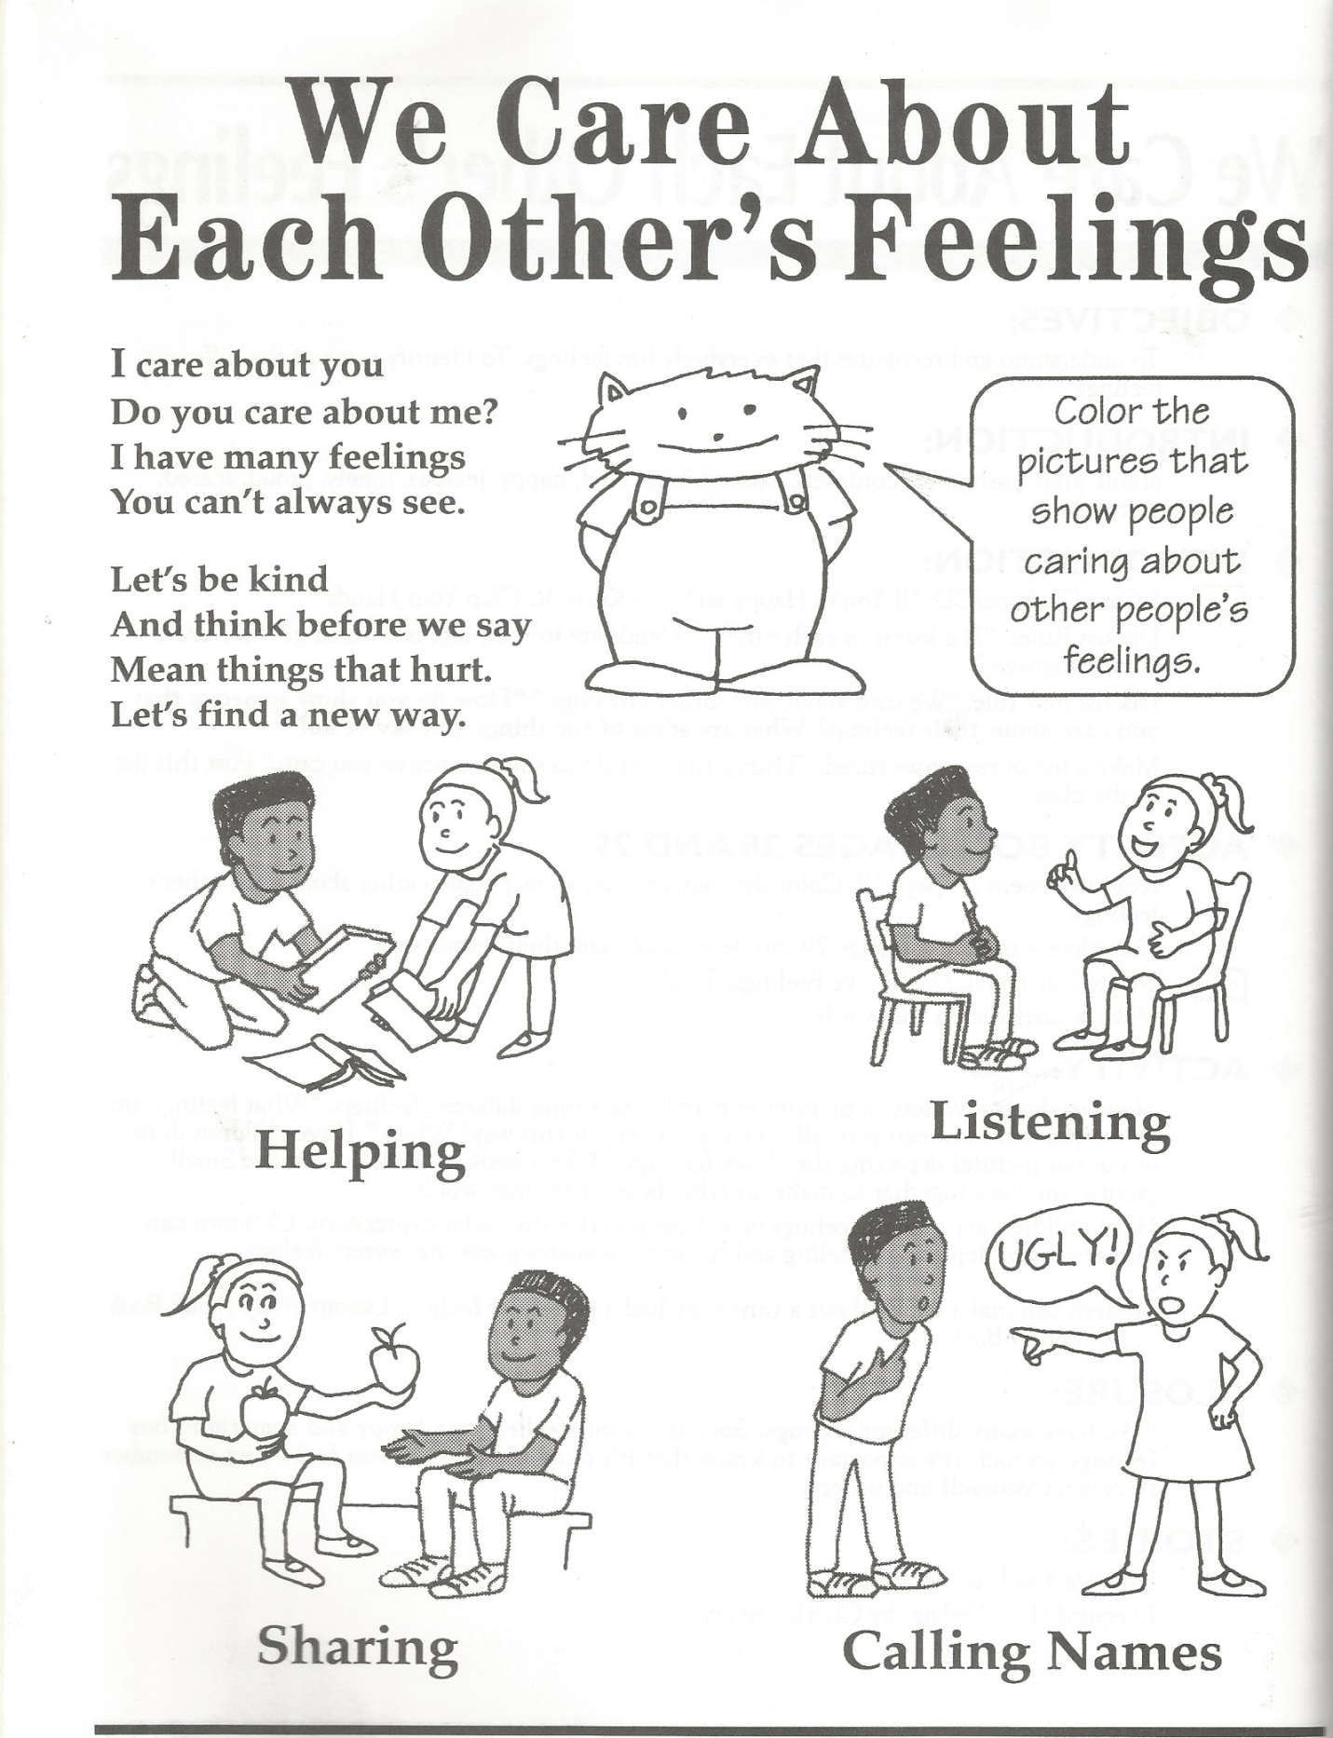

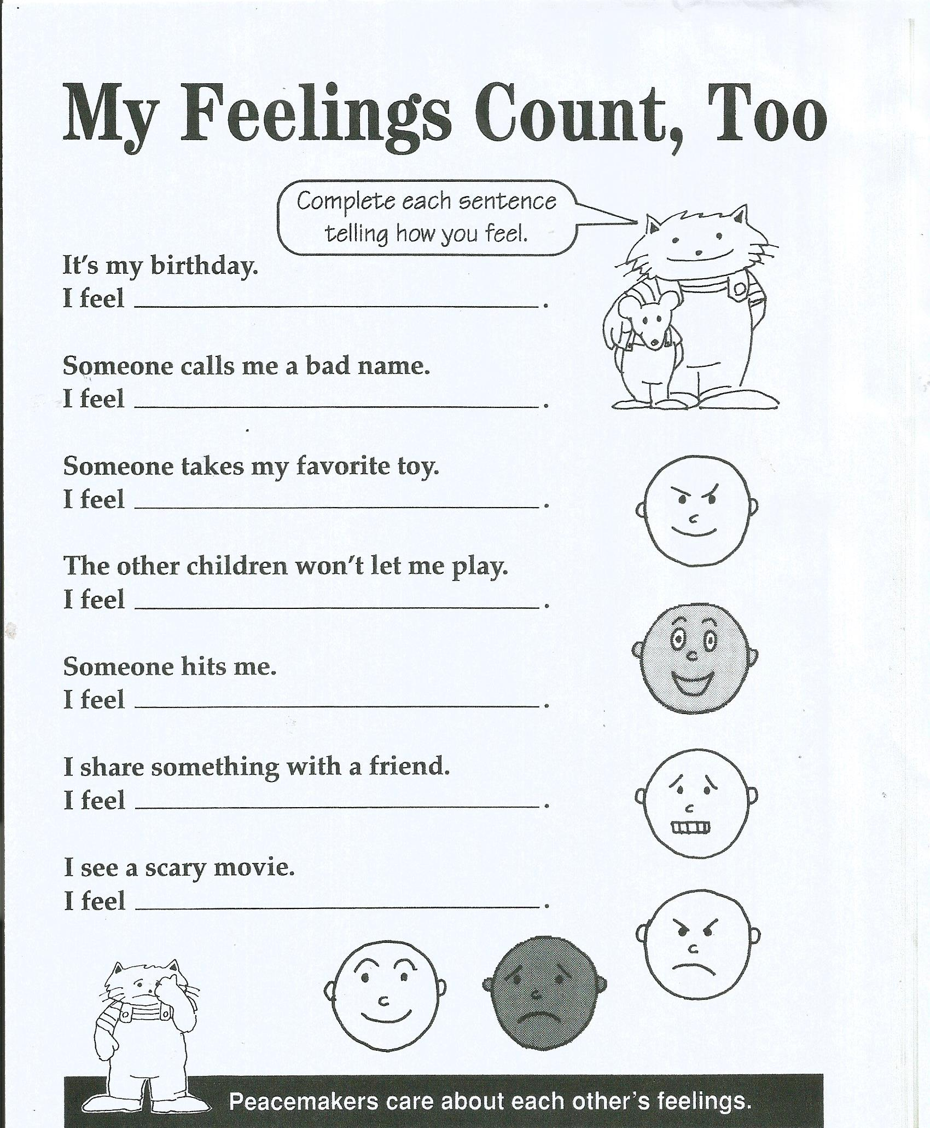

■Talk It Out Together (Grade 4)
Procedure:
- Display the “Talk it Out Together” conflict-solving chart and read the steps. See below.
- Explain that the “Talk it Out Together” method is a problem-solving process that is easy to learn and apply.
- Tell the children that
    - you will be reading some conflict scenes to them
    - you want them to use the Talk It out Together method to come up with positive solutions to the conflict
    - first, you will do a practice story with them.
- Read the Practice Story below to the children and then apply the method as demonstrated.

Practice Story:
Cheryl and Marcia are cleaning up after an activity. They both pick up the same book and start
pulling at it to get it. Cheryl pushed Marcia and she fell and started to cry.

- Say to the children: Cheryl and Marcia seem to have a problem. Let’s use the Talk It Out Together’ method to solve this conflict.

Step 1: Get together. Cheryl and Marcia come together and face each other.
Step 2: Take turns talking and listening. Cheryl and Marcia take turns talking about how they feel about what happened.
Step 3: What will help? Cheryl and Marcia take turns suggesting ideas and plans that would help them both feel better.
Step 4: Choose a plan. Cheryl and Marcia suggest two plans that are agreeable to both of them.
Step 5: Do it! They pick the plan and implement it.

- Now read the stories below and have the children practise applying the Talk It Out Together method.

Story 1:
“Jermaine and Janet sat at the same desk. Jermaine asked Janet if he could borrow a pencil.
Janet was trying to hear the teacherm so she said, “Shut up!”
This made Jermaine mad, so he pulled Janet’s hair.
Janet punched Jermaine in the arm.
Jermaine pushed Janet’s books to the floor.
The teacher said, “What’s going on over there?”
Jermaine and Janet both pointed to each other and said, “He/She started it!”

Story 2:
Stephen and Mark were working on a puzzle together. Stephen took a piece from
Mark and put in place. Stephen got mad and wrecked the puzzle. Then he told the
teacher that it was Mark’s fault.
Mark said, “He is a tattle-tale and he is a big, fat liar!”

- Invite the children to share stories of conflict to which they would like to apply the Talk It Out Together method.
- Have children make a Talk It Out Together chart for the classroom.

Talk it Out Together Chart
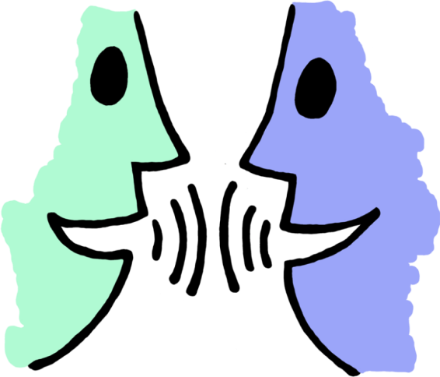
Step 1: Get together.

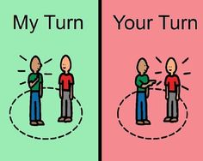
Step 2: Take turns talking and listening.

Step 3: What will help?

Step 4: Choose a plan.

Step 5: Do it!

■ What Makes Me Angry? What Can I Do? (Grades 5 & 6)
Objectives:
- To identify what makes students angry.
- To identify strategies that will help students to feel better without hurting others.

Procedure
- Say to the children: Have you ever felt angry? I have. Everyone feels angry sometimes. What happens to your body when you feel angry (gets sweaty, shout)? Let’s talk about what makes us angry and what we can do when we are angry to feel better.
- Have the children brainstorm all of the things that make them angry.
- Write their responses on the board.
- Have them brainstorm all the things that help them calm down.
Calming Down at School
Calming Down At Home
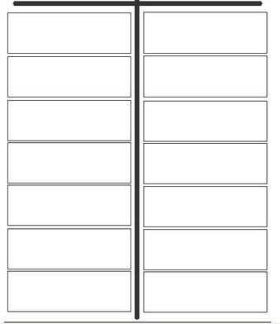
- Write their responses on the board.
- Help them decide which techniques they can use to calm down at
home and which ones they can use at school.
- In their notebooks, have them draw a T-chart and have them list
the techniques under the headings “Calming Down at Home” and “Calming Down at School”.
- Have students read the poem at “What Makes Me Angry” below and complete the sentences.
- Say to them: “It’s Okay to be angry, but it is not okay to hurt someone because you are angry. What can you do when you get angry so that you do not hurt anyone and you help yourself feel better?
- For the “What Can I Do” activity below, have students draw two pictures showing what they can do.

Teaching Point:
Say to students: “We all get angry sometimes. It is okay to be angry but that doesn’t give us the right to hurt ourselves or others. There are many things we can do to calm down. We can help each other to think before we act about what we do and what the results will be.”

Additional Activities:
- Have students do role plays illustrating real-life situations of when they were angry and how the situation turned out. Discuss with them the feelings involved and techniques that could be used to calm down.
- Make up lines to the song “If You Happy and You Know It” to talk about managing anger. For example:
“If you happy and you know it
Hit a pillow …
If you happy and you know it
Run a mile …
If you happy and you know it
Play a game …
If you happy and you know it
Count to 10 …”
Etc.

